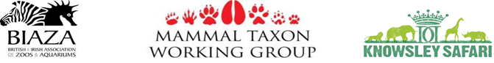
On Tuesday 16th of October BIAZA held its annual three day mammal taxon working group at Knowsley Safari Park in Liverpool. BIAZA is the British and Irish Association of Zoos and Aquariums, it represent over 100 zoo and aquarium members who pride themselves on their excellent animal welfare, education and conservation work. BIAZA leads and supports its members and helps promote the work of good zoos and aquariums.
Sparsholt College is a member of BIAZA which means as a collection we cohere to their codes of practice and support the organisation.
Currently I hold the position of co-chair on the small mammal focus group, a sub group amongst the mammal groups which includes Carnivores, Primates, Hoofstock and Elephants. The Mammal taxon group provides support to institutions and keepers, the main focus being:
•inspire people to help conserve mammals, by participation in effective co-operative mammal conservation programmes
•deliver the highest quality environmental education, training and research relating to mammals
•achieve the highest standards of mammal care and welfare in zoos, aquariums and the wild.
This year at the annual meeting I volunteered to run a workshop on nutrition. Nutrition in zoos has fast become a focus point for many keepers. Improving animal health and behaviour through adaptation of diets is being practiced in many collections through trials research and studies.
The workshop involved a practical element where keepers explored the park inspecting diets and faecal matter and questioning keepers regarding health, this then lead to a workshop involving diet preparation. With the help of Andy Beer at Sparsholt and also a keeper at the Manor house wildlife park who donated the Common Marmosets here at the college, we were able to run a very successful workshop with some real positive feedback from keepers from all around the U.K
The workshop was aimed to provide keepers with evidence and reason to consider changing diets in order to improve behaviour and health in zoo animals. Here at the college we have been visiting many of our own diets and making changes which have improved health and welfare of many of our species, good examples of this can be seen with the Meerkats and Common Marmosets.
For the remainder of the three day event there were many talks and presentations involving animal training, hand rearing and general husbandry, with some very interesting talks on health care and what works well and sometimes not so well in zoo institutes.
These events give animal keepers the chance to exchange knowledge, learn new things and develop their specialised skills. They provide an excellent opportunity to mix with other animal based people and to network .
If you are interested in the work BIAZA in involved with then take a look at their website http://www.biaza.org.uk/home/

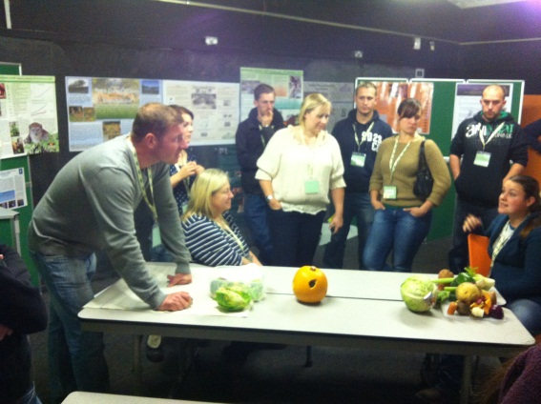
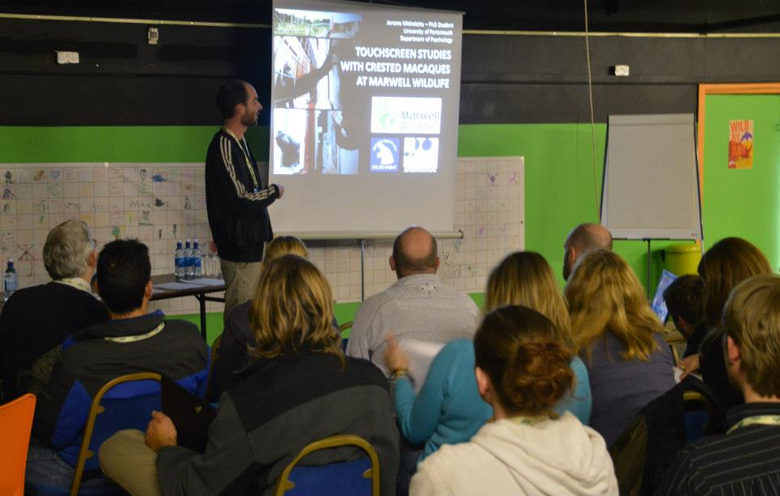
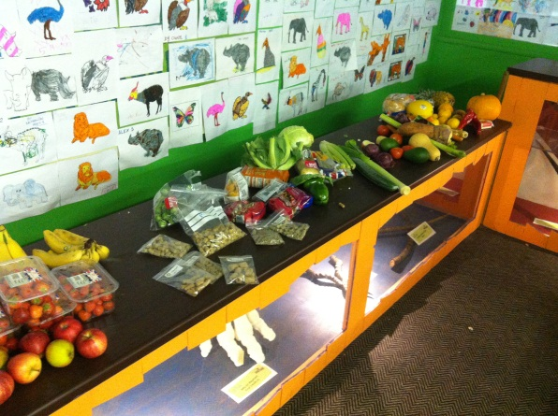
Presentation on animal training
Nutrition workshop
Nutrition workshop

