Wolf Data Worksheet
Use the following code to create a dataset called ‘wolf’:
n <- 48
packs <- c("North", "South", "East", "West")
pack_assignments <- rep(packs, each = n / length(packs))
wolf <- data.frame(
wolf_id = paste0("W", sprintf("%03d", 1:n)),
age_years = sample(1:12, n, replace = TRUE),
weight_kg = round(rnorm(n, mean = 45, sd = 8), 1),
pack = pack_assignments,
daily_km_traveled = round(rlnorm(n, meanlog = 2.5, sdlog = 0.3), 1)
)
When loaded into R, it will give you a data set that looks like this:
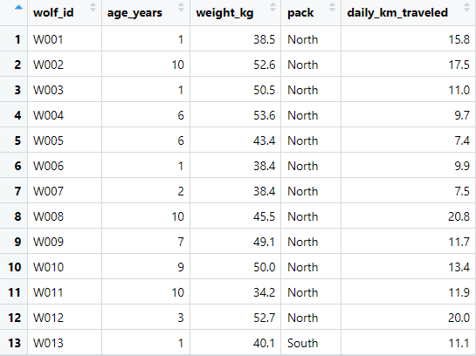

Use the data to answer the questions below.

Research Question: Does wolf weight differ between different packs?

1️⃣ Data Understanding
- What variables are included in the dataset?
Response: ____________________________________________________
Predictor: ____________________________________________________
- What type of variable is ‘pack’ (categorical or continuous)?
- What type of variable is ‘weight_kg’?
2️⃣ Data Exploration
- What is the mean weight of wolves in each pack?
4️⃣ Hypothesis Formulation
- Write the null hypothesis (H₀) for the research question ‘Does wolf weight differ between different packs?’.

- Write the alternate hypothesis (H₁).
5️⃣ Statistical Testing
- Choose an appropriate statistical test to test the null hypothesis you’ve written in question 5.
- Which test did you choose — and why?
- What are the test statistics and p-value?
- Do you need to run any post-hoc tests? Explain the reasoning for your answer.
- Based on your results, do you accept or reject the null hypothesis – and why?
6️⃣ Interpretation & Discussion
- Summarise your results in one or two sentences.
- Use a suitable graph to display the weight of wolves in each pack, and paste a copy of the graph here:

