Snake Data Worksheet
Use the following code to create a dataset called ‘snake’:
n <- 40
snake <- data.frame(
species = rep(c("Copperhead", "Rattlesnake"), each = n),
length_cm = c(
rnorm(n, mean = 75, sd = 10), # Copperheads
rnorm(n, mean = 110, sd = 15) # Rattlesnakes
)
)
View(snake)
attach(snake)

When loaded into R, it will give you a data set that looks like this:
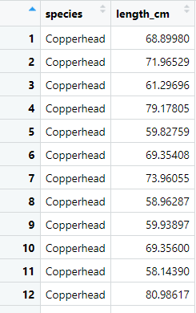

Research Question: Does the snake length differ between the two different species?

Data Understanding
- What variables are included in the dataset?
Independent:
Dependent:
Hypothesis Formulation
- Write the null hypothesis (H₀) for the research question ‘Does the snake length differ between the two different species?’
Statistical Testing
- Choose an appropriate statistical test to test the null hypothesis you’ve written.

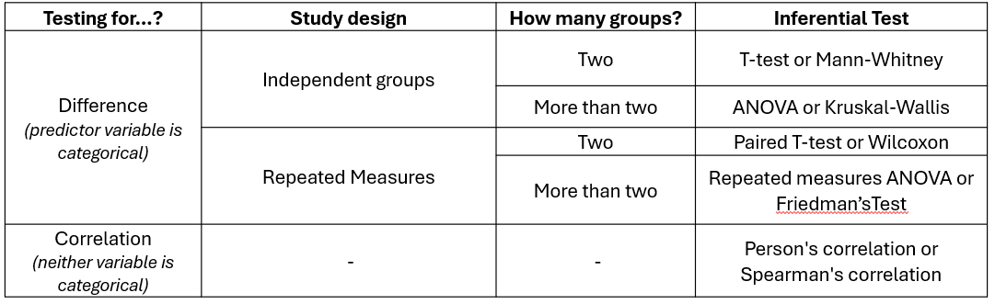

- Which test did you choose — and why?
- What are the test statistics and p-value?
- Based on your results, do you accept or reject the null hypothesis – and why?

Interpretation & Discussion
- Summarise your results in one or two sentences.
- Use a suitable graph to display the length of snakes of each species, and paste a copy of the graph here:

