Deer Data Worksheet
Use the following code to create a dataset called ‘deer’:
n <- 50
deer <- paste0("D", sprintf("%03d", 1:n))
baseline <- rlnorm(n, meanlog = 2.2, sdlog = 0.25)
summer_km <- baseline * runif(n, 1.05, 1.20)
winter_km <- baseline * runif(n, 0.80, 0.95)

deer <- data.frame(
summer_km = summer_km,
winter_km = winter_km
)

View(deer)
attach(deer)
When loaded into R, it will give you a data set that looks like this:
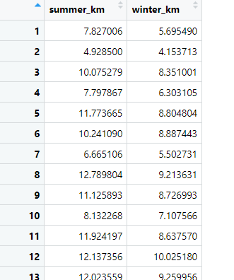

50 deer were included in this study. The distance that each deer travelled (km) was recorded for two seasons (summer and winter). Use the data to answer the questions below.

Research Question: Does the distance that deer travel differ between seasons?

1️⃣ Data Understanding
- What variables are included in the dataset?
Response: ____________________________________________________
Predictor: ____________________________________________________
2️⃣ Data Exploration
- What is the mean distance that deer travelled in the summer?
- What is the mean distance that deer travelled in the winter?
4️⃣ Hypothesis Formulation
- Write the null hypothesis (H₀) for the research question ‘Does the distance that deer travel differ between seasons?’.

- Write the alternate hypothesis (H₁).
5️⃣ Statistical Testing
- Choose an appropriate statistical test to test the null hypothesis you’ve written in question 4.
- Which test did you choose — and why?
- What are the test statistics and p-value?
- Based on your results, do you accept or reject the null hypothesis – and why?
6️⃣ Interpretation & Discussion
- Summarise your results in one or two sentences.
- Use a suitable graph to display the distance travelled in each season, and paste a copy of the graph here:

