Deer Data Worksheet
Use the following code to create a dataset called ‘deer’:
n <- 50
deer <- paste0("D", sprintf("%03d", 1:n))
baseline <- rlnorm(n, meanlog = 2.2, sdlog = 0.25)
summer_km <- baseline * runif(n, 1.05, 1.20)
winter_km <- baseline * runif(n, 0.80, 0.95)

deer <- data.frame(
summer_km = summer_km,
winter_km = winter_km
)

View(deer)
attach(deer)
When loaded into R, it will give you a data set that looks like this:
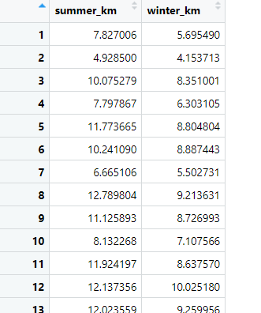

50 deer were included in this study. The distance that each deer travelled (km) was recorded for two seasons (summer and winter). Use the data to answer the questions below.

Research Question: Does the distance that deer travel differ between seasons?

1️⃣ Data Understanding
- What variables are included in the dataset?
Response: distance travelled by deer (km)
Predictor: season (summer, winter)
2️⃣ Data Exploration
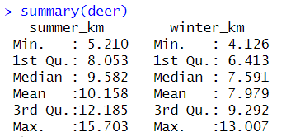
- What is the mean distance that deer travelled in the summer? 10.16 km

- What is the mean distance that deer travelled in the winter? 9.98 km
4️⃣ Hypothesis Formulation
- Write the null hypothesis (H₀) for the research question ‘Does the distance that deer travel differ between seasons?’.
There will be no significant difference in the distance (km) that deer travel between summer and winter

- Write the alternate hypothesis (H₁).
There will be a significant difference in the distance (km) that deer travel between summer and winter

5️⃣ Statistical Testing
- Choose an appropriate statistical test to test the null hypothesis you’ve written in question 4.
- Which test did you choose — and why?
As the study follows a repeated measures design, and there are two categories within the categorical predictor variable, either a paired t-test (if normally distributed) or a Wilcoxon test (if not normally distributed) will be used to test the null hypothesis.
A Shapiro-Wilk test was run to determine whether the difference between the distance travelled by deer was normally distributed. The output of the Shapiro-Wilk test was W=0.952, P=0.043, showing that it was not normally distributed. Consequently, a non-parametric test will be used – Wilcoxon test.
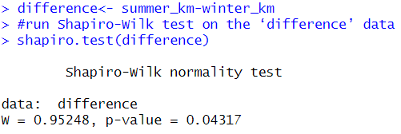
- What are the test statistics and p-value?

A Wilcoxon signed rank test with continuity correction was run to determine whether the distance travelled by deer differed between summer and winter.

A significant difference was seen (W = 1275, p-value = 7.79e-10), with deer travelling a greater distance in the summer (Median : 9.582) compared to the winter (Median : 7.591).
- Based on your results, do you accept or reject the null hypothesis – and why?
As a significant difference was identified, the null hypothesis should be rejected.
6️⃣ Interpretation & Discussion
- Summarise your results in one or two sentences.
A Wilcoxon signed rank test with continuity correction was run to determine whether the distance travelled by deer differed between summer and winter. A significant difference was seen (W = 1275, p-value = 7.79e-10), with deer travelling a greater distance in the summer (Median : 9.582) compared to the winter (Median : 7.591).
- Use a suitable graph to display your results, and paste a copy of the graph here:
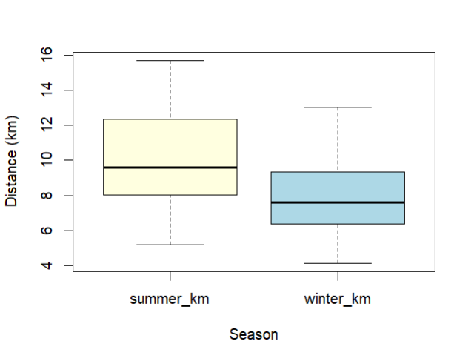

newformat <- deer %>%
pivot_longer(
cols = c(summer_km, winter_km), # list or use starts_with(), matches(), etc.
names_to = "Season",
values_to = "Distance"
)

boxplot(newformat$Distance~newformat$Season, xlab = "Season", ylab = "Distance (km)", col = c("lightyellow", "lightblue"))

