C:\Users\jgarner.SCH\AppData\Local\Microsoft\Windows\Temporary Internet Files\Content.IE5\51G865KX\MC900078625[1].wmfDocking blocks – i.e. posting blocks to the side of the classroom (see a )

PLEASE NOTE: Note that this is for just your view of the page.

1. Docked blocks

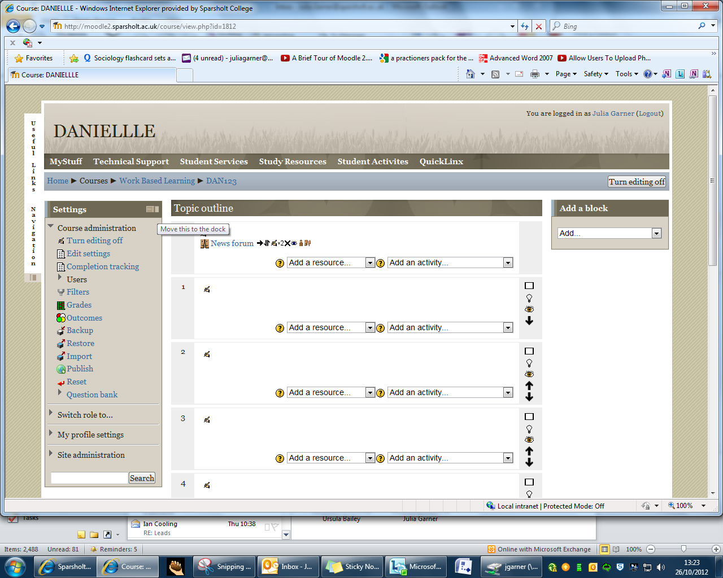

To move or dock this block hover over the rectangles top right of block and select ‘dock this block’

Un-docked block