Top Tips for Tackling Your Dissertation (and Coming Out Smiling)

- Pick a Topic That Sparks Your Curiosity
You’re going to live and breathe this project for months — so choose something that genuinely excites you. Interest is your best fuel. If you find yourself asking questions about it over coffee, you’re probably onto a winner.
- Know Your ‘Why’
Nail down clear research questions and objectives early on. They’ll keep you on track when things get busy (or muddy, if you’re in a field somewhere).
- Do Your Homework (a.k.a. Literature Review)
Read widely. Know what’s already been done. Spot the gaps. This is your chance to join the academic conversation, not just repeat it.
- Talk to Your Supervisor – Often
They’re not just a name on a form. Supervisors can save you from dead ends, help refine your ideas, and sometimes offer the exact bit of wisdom you need. Use them.
- Plan Fieldwork Like a Pro
Good data doesn’t collect itself. Be meticulous. Be safe. Be ethical. And remember — methods need to be repeatable and justified, not improvised on the day.
- Tame Your Data
Keep your data neat, labelled, and backed up. Use software that works for you (Excel, Minitab, R… whatever fits). Future You will thank Past You.
- Stats Don’t Need to Be Scary
You’re assessed on the right analysis, not the most complicated one. A simple test done correctly beats a complex one done badly. Let your experimental design guide your stats.
- Stay Safe Out There
Fieldwork is fun… until it’s not. Complete your ethical review, follow safety protocols, and don’t take risks. Your well-being comes first.
- Time Is Your Friend (If You Plan Ahead)
A realistic timeline is gold. Break the work down. Deadlines won’t feel like cliff edges if you’ve built good steps.
- Find Your Dissertation Crew
Chat with classmates, share tips, moan about the rain together, and celebrate the wins. Peer support makes the process more human.
- Read Like a Scientist, Write Like a Pro
Spot what makes some papers sing and others sink. Emulate the good ones. Aim for writing that’s clear, sharp, evidence-based — and makes the reader actually want to keep reading.
- Reference as You Go (Future You Will Cheer)
Keep track of every source. A reference manager will save you hours (and tears) later.
- Let Your Graphs Do the Talking
Well-designed figures can elevate your dissertation. Pick the right graph for your data, label everything clearly, and make it publication-worthy.
- Drafts Are Part of the Deal
No one nails it first time. Good writing is rewriting. Embrace feedback — it’s how good work gets great.
- Polish to Shine
Grammar and typos can dull brilliant ideas. Proofread. Use support tools. Ask a friend for a fresh pair of eyes.
- Keep Asking Questions
Stay curious. Curiosity leads to deeper understanding — and sometimes unexpected discoveries that make your dissertation sparkle.
- Back Up. Then Back Up Again.
Cloud, USB, external hard drive… whatever works. Just don’t put months of work at the mercy of one laptop.
- Enjoy the Ride
This is your chance to dive deep into something you care about. It’s not about perfection — it’s about learning, growing, and maybe discovering something new. By the end, you’ll know something few others do. Own that.

How to display critical thinking in your work
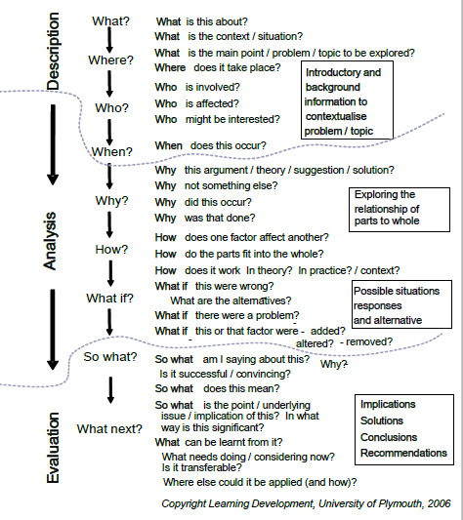

The flow chart below is designed to help you to develop and display critical thinking in your work. Mastery of this will help towards achieving a top-class high-quality dissertation and a truly enquiring mind. Each point of this critical thinking path may not always apply but you must include many aspects from all sections Description, Analysis and Evaluation in your dissertation.

